Bloom’s Taxomony New Version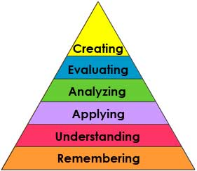

|  |  |
| --- | --- |
| **Remembering:** can the student recall or remember the information? | define, duplicate, list, memorize, recall, repeat, reproduce state |
| **Understanding:** can the student explain ideas or concepts? | classify, describe, discuss, explain, identify, locate, recognize, report, select, translate, paraphrase |
| **Applying**: can the student use the information in a new way? | choose, demonstrate, dramatize, employ, illustrate, interpret, operate, schedule, sketch, solve, use, write. |
| **Analyzing**: can the student distinguish between the different parts? | appraise, compare, contrast, criticize, differentiate, discriminate, distinguish, examine, experiment, question, test. |
| **Evaluating**: can the student justify a stand or decision? | appraise, argue, defend, judge, select, support, value, evaluate |
| **Creating**: can the student create new product or point of view? | assemble, construct, create, design, develop, formulate, write. |

<http://www.odu.edu/educ/roverbau/Bloom/blooms_taxonomy.htm>